The first two images are the new instance creation and attaching the volume which I have created mounting is shown in 2nd image

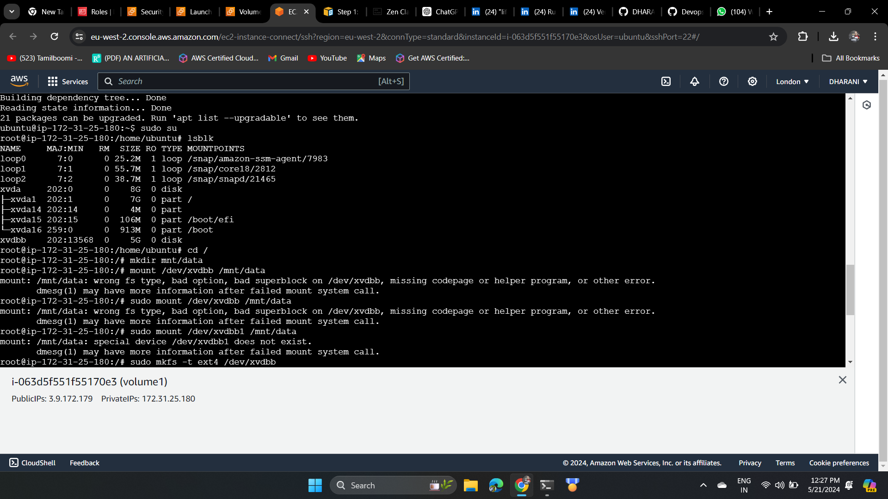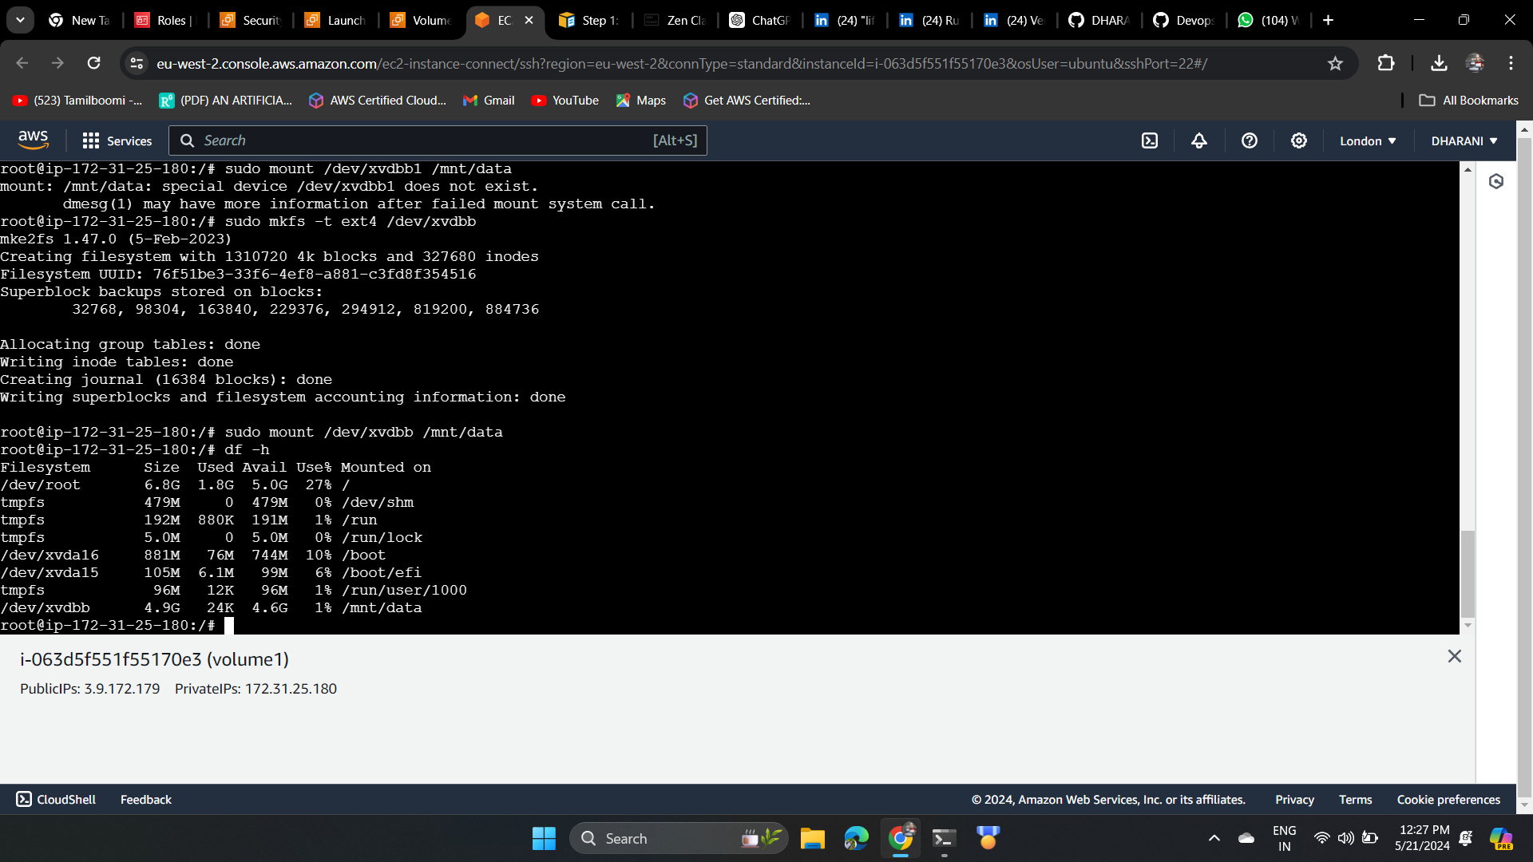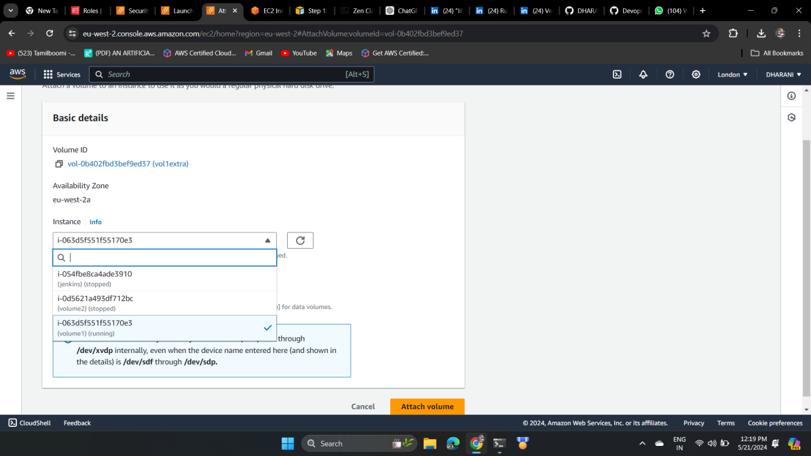

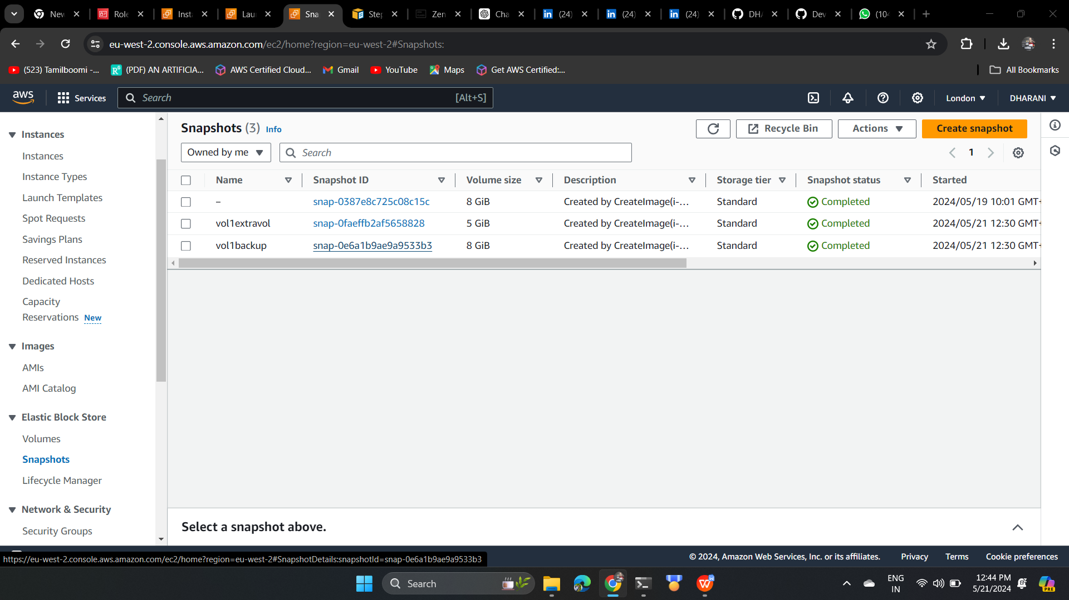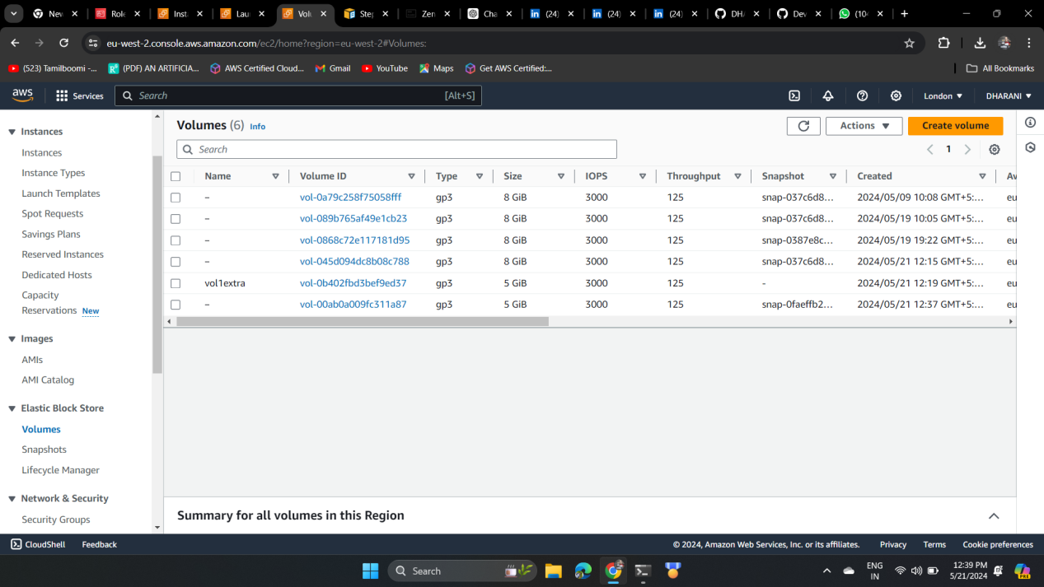

The above image is the when volume newly created which I have named vol1back up   
and from snapshot I have created volume which is listed in the last vol id:a87